Queues Management Application

Assignment 2

NUME STUDENT: Voicu Sara-Ioana
GRUPA: 30421

CHAPTERS

1. Objectives 3
2. Analyzing the problem and the Use-Cases 3
3. Design 5
4. Implementation 7
5. Results 8
6. Conclusion 9
7. Bibliography 9

Objectives
The main purpose of this application is to create a queue management system that implements efficient queue allocation mechanism, by using threads and synchronization.
Other sub-objectives are:
-Analyzing the problem and the requirements
-Designing the graphical interface of the queues management system
-Implement the simulation application
-Test the simulation application

Analyzing the problem and the Use-Cases
Analysis: Queues are commonly seen both in real world and in the models. The main objective of a queue is to provide a place for a "customer" to wait before receiving a "service". The management of queues systems is interested in minimizing the time amount its "customers” are waiting in queues, in order to have a more efficient service and to satisfy the needs of the customers and employees.

Functional requirements:
-The simulation application should allow users to setup the simulation
-The simulation application should allow users to start the simulation
-The simulation application should display the real-time queues evolution
-The simulation application should display the average waiting time, average service time and the peak hour

Modelling the problem: There are different methods in which the problem can be solved, either by finding the queue that has the minimum number of clients or by selecting the queue with the minimum total service time, in the case where we know the service time of each customer. As we do have the service time for each customer, I chose the implement the second method, as it seems to be the most efficient.

Input data:
-Minimum and maximum interval of arriving time between customers
-Minimum and maximum service time
-Number of queues
-Simulation interval
-Number of clients

Output data:
-average waiting time, service time and peak hour
-log of events and main system data
-queue evolution

Use-Cases Diagram:
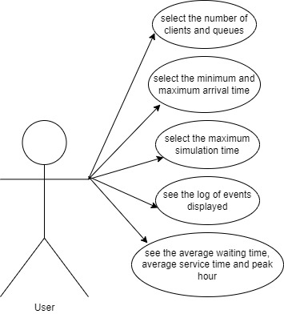

Use Case 1: select the number of clients and queues
Primary Actor: user
Main Success Scenario: the user is able to choose and insert the number of clients and the number of queues, so he/she can design the queue management system. The number is not limited.

Use Case 2: select the minimum and maximum arrival time/service time
Primary Actor: user
Main Success Scenario: the user should insert the minimum and then the maximum arrival time/service time. The arrival time represents the time when the client arrives at the queue, no matter if there are or not other clients at that queue. It should also depend on the simulation time. The service time represents the total time that a client needs in order to satisfy his/her services.

Use Case 4: select the maximum simulation time
Primary Actor: user
Main Success Scenario: the user should insert on the interface the maximum time for the simulation. The simulation may stop in 2 different situations: either when it reaches the maximum simulation time, or when all the clients have been satisfied and there are no more waiting clients.

Use Case 5: see the log of events displayed
Primary Actor: user
Main Success Scenario: after pressing the start button, the simulation starts and the user can see displayed on the interface all the events that happened

Use Case 6: see the average waiting time, average service time and peak time
Primary Actor: user
Main Success Scenario: the client can also see some other things that the application calculated for him/her.
For example, the average waiting time, the average service time and the peak hour. Peak hour represents the hour when there were the most clients at a queue.

Design
The class diagrams are used in designing and modelling the software. The diagrams describe the classes and their relationships. They enable us to model software in a high level of abstraction and without having to look at the source code. The classes are described by including the attributes, objects and the methods from a specific class. On top we have the name of the class and below it the attributes. A minus in front of the attribute means that the attribute is private. The constructors, getters, setters and methods are listed below the attributes.
What are the benefits of UML diagrams? They are very flexible and easy to draw, and in this way, you can communicate the software architecture effectively.

The UML Diagram:
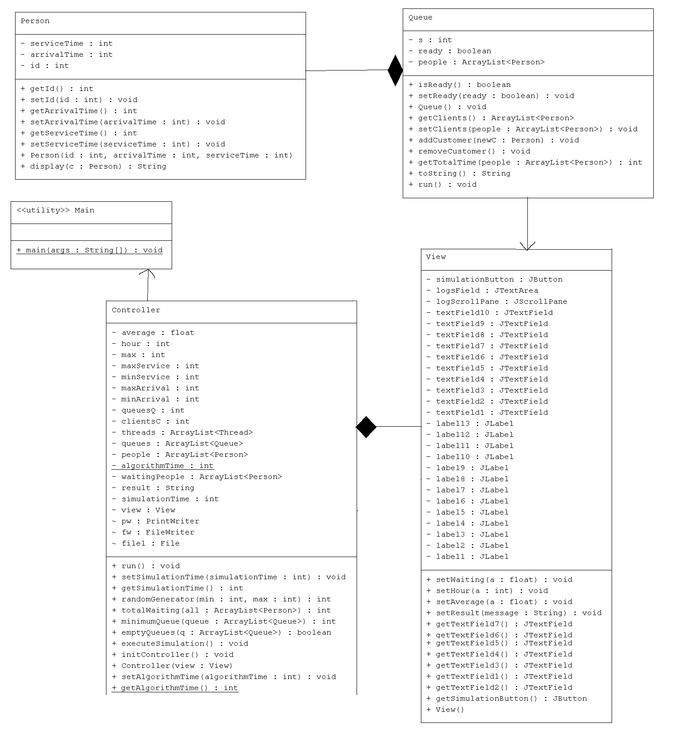

Data structures: The data structures used in this project are mostly primitive types, especially integers and strings, but also complex types such as ArrayList type objects or Lists.
The lists were used for storing new created objects such as Person or Queue type of objects. ArrayLists are more efficient regarding the memory management, performance and provide a faster access to their content than regular arrays.

Packages: A package in Java is used to group related classes. They are used in order to avoid name conflicts and to write a better maintainable code. The project is organized in 4 packages: application, model, view and controller. In an object-oriented development, model-view-controller (MVC) is the name of a methodology or design pattern for successfully and efficiently relating the user interface to underlying data models.
Model: it represents the business layer of application; it carries the data that can also contain the logic to update controller if data is changed. The model package contains the classes Person and Queue, representing the clients that are waiting at different queues.
View: it represents the presentation layer of application. It is used to visualize the data that the model contains. The view package contains the View class, where the components that form together the interface are described and declared.
Controller: It works on both the model and view. It is used to manage the flow of application, i.e., data flow in the model object and to update the view whenever data is changed. The controller package contains only the Controller class, which makes the connection between the interface and the user, by using action listeners.
The last package is application, which contains a single class that has the customary main() method.

The Graphical Interface:

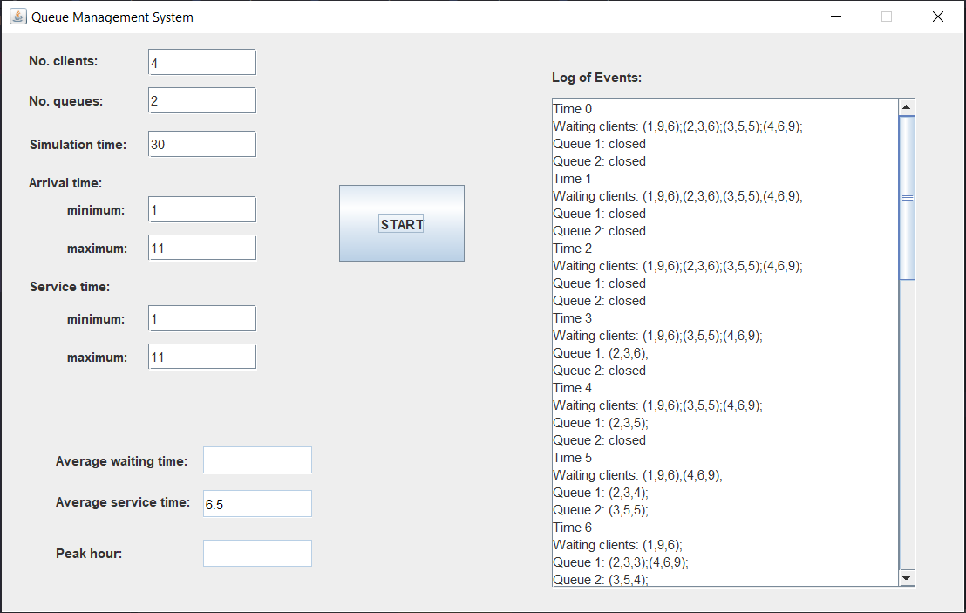

The graphical interface is mostly described in the class View, package view. It extends the JFrame class, which represents a top-level container that renders a window on the screen and it has the following attributes:
- 13 labels for describing different data that the user must introduce on the interface
- 10 text fields where the user can introduce the data; the last three are disabled because we want to display some results there, so the user is not allowed to introduce any data there
- A scroll pane, because we have a lot of data to display so we will need to scroll through it on the interface
- A button: when you press the START button the application starts executing

Implementation
Multithreading in Java is a process of executing two or more threads simultaneously to maximum utilization of CPU. Multithreaded applications execute two or more threads run concurrently. Hence, it is also known as Concurrency in Java. Each thread runs parallel to each other. Multiple threads don’t allocate separate memory area, hence they save memory. Also, context switching between threads takes less time.
start() - this method starts the execution of the thread and JVM calls the run() method on the thread
sleep(int milliseconds) - this method makes the thread sleep hence the thread’s execution will pause for milliseconds provided and after that, again the thread starts executing. This help in synchronization of the threads

The Person class, inside the model package describes the attributes of a person: he/she has an id, an arrival time and a service time. The class also includes some getters and setters, constructor and a method to display the persons that are waiting in a list before entering any queue.

The Queue class, inside the model package contains a list of clients and a ready attribute of boolean type. While ready is true, it means that we can still perform operations on the queue. When ready is false, it means that our thread doesn’t run anymore. This class implements the Runnabe interface and contains the method run(). We will have a thread for each queue. The methods implemented by this class are:
- getTotalTime: it calculates the total service time from a list of clients
- addCustomer: it adds a person to a queue
- removeCustomer: it removes the first person in the queue, when his/her service time becomes zero
- toString: this represents a method that displays the Queues
- run: this is a method that runs as long as ready is true, as long as we can still perform operations on a queue; it subtracts one from the serviceTime of the first client in the queue, as the algorithm simulation time goes by; when the service time becomes 0, it removes the person

The Controller class, inside the controller package has the method initController() which has the purpose to initialize the controller, so it contains an action listener. The action listener acts whener the user presses the button Start and then it has to perform the method executeSimulation().
As the methods says, it performs the simulation of the queue management system. This class implements the Runnable interface and contains the method run(). Here we will perform the main thread of the application.
The methods are the following:
- executeSimulation(): here we read the data from the interface and then we initialize the persons by using a random generator and then the queues and also the threads, one for each queue; also, we start the main thread here
- emptyQueues: this is a method that verifies if all queues are empty or not
- minimumQueue: this is a method that calculates the queue with the minimum service time, so that we will know where we need to add the next person, in order to have an efficient management system
- totalWaiting: calculates the total service time of the clients for all the queues
- run: in this method we will start all the threads for each queue; while they are running at the same time, we need to perform some operations on the queues; we will find the minimum queue and we will add the next person to that queue; we don’t need to forget to remove the client from the waiting list; at each hour we will modify the queues and we will display the result on the interface; the method ends when there are no more clients or when the simulation time ended

The Main class has only one method, main, where we instantiate the view and initialize the controller, so that the user can play with the application.

Results
For this project we were asked to test our queues management system on 3 different examples, starting from a small number of clients, to a huge one. I included all the text files in the source folder of my project that I uploaded on GitLab, but I will also display my own example here, as I chose small numbers that can be easily seen.
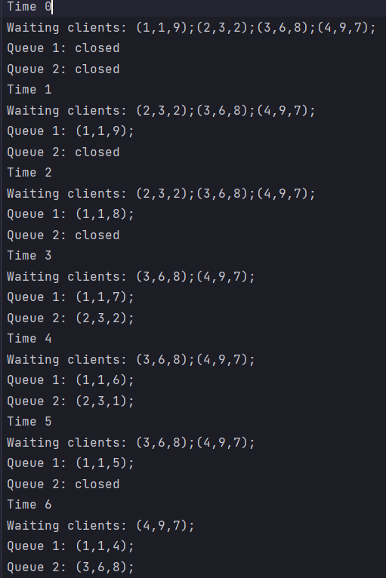

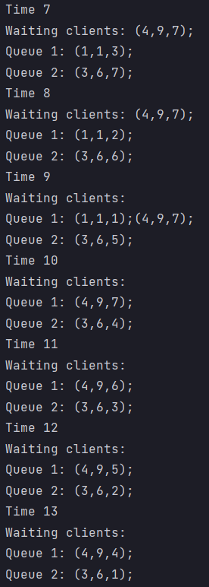
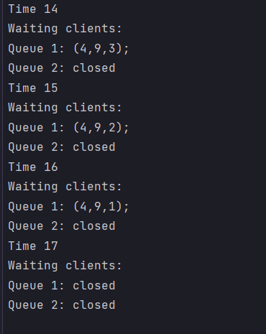

Conclusion
This project was a good exercise for improving OOP concepts and for improving the skills that I learned in the first semester of this year. I found it very challenging.
In the future, I would like to be more organized as I found out that having a good image of the project before starting to implement and write code and having the problem already organized in my mind and on paper helps a lot. It reduces time and work, and everything seems more clear and easier to work with. I also came to the conclusion that facing problems with your code and trying to solve them by yourself will obligate you to do a lot of research and you can learn better from it. After ending this project, I learnt better how to work with threads, especially multithreading. I found it difficult at first, I couldn’t synchronize the threads from the start, but as I did some research and read the presentation for this project and the course, I managed to finish the project. It was a very interesting one, and we were facing a problem that we may encounter in the real world as well.
.

Bibliography

- Object Oriented Programming – lectures of prof. Marius Joldos
- Programming Techniques – lectures of prof. Cristina Bianca Pop
- www.stackoverflow.com
- Bro Code – YouTube channel

